INSTRUCTION SHEET
IS-41
ATE Spring Probes

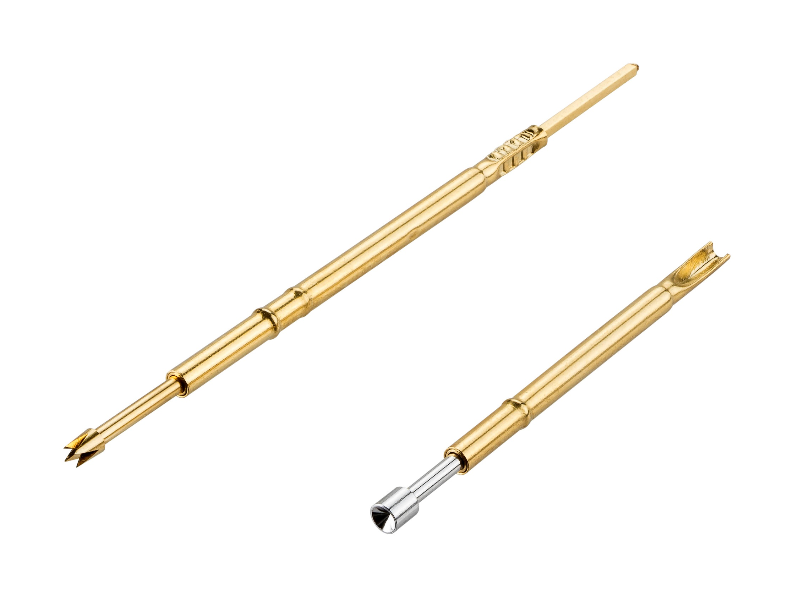

CONTENTS
Section Page
Introduction 2
Two Part Spring Probes
Overview 3
Mounting the Sleeve 3
Sleeve Wire Attachment 4
Assembling the Probe 5
Removing the Probe 5
One Part Spring Probes
Overview 6
Mounting the Probe 6
Probe Head Variants 7
Care and Maintenance 7

INTRODUCTION
ATE Spring Probes are suitable for use on test jigs and automatic test equipment (ATE) to enable the fast testing of multiple points on a PCB or sub-assembly.
Typically, spring probes are mounted in an inert substrate block, on a grid or custom layout (known as a “bed-of-nails”). This block is mounted into a piece of test equipment, such that the array of probe heads are lowered down to make contact with the PCB being tested. The “bed-of-nails” makes contact with all the relevant test locations in one operation. The testing equipment is cabled into the back of every probe, and readings are taken automatically from all the probes.
Using this method, every PCB or sub-assembly is measured in the same way, at the same locations, so any variation due to operator probing can be eliminated.
One-Part and Two-Part Spring Probes
There is a choice of probe type for these test equipment beds:
- One Part the complete probe is assembled into the equipment. To replace a worn-out probe, the whole probe must be de-wired and removed. This is suitable for lower-use applications.
- Two Part if the throughput is much higher, and the risk of wearing out the probe is greater, this is the better choice. The sleeve is a permanent fixture to the equipment and the wiring. The probe is pushed into the sleeve – and can be pulled out and replaced when the probe becomes worn out or damaged.

Two part Spring probes
Overview
The Two Part Spring Probe is purchased as two separate components:
PROBE
Travel
Indent (holds Plunger and Spring in Body)
Head
Plunger
Body (containing Spring)
SLEEVE
Retention Ring
Indent (holds Probe in Sleeve)

Area to hold probe
Wire assembly area

Mounting the Sleeve
The sleeve is designed to be mounted into the test bed. There are two choices on assembly. Depending on the style of wire attachment, this can be carried out before or after the sleeve is assembled into the test bed.
- Use the Retention Ring as a shoulder.
The sleeve is installed into the test bed through a clearance (loose fit) hole, until the Retention Ring is resting on the mounting plate. This could be either side of the plate. The sleeve can then be soldered, fixed with epoxy or glued into place. This gives a fixed projection height relative to the mounting plate surface.
- Use the Retention Ring for interference fit.
With the right size hole in the mounting plate, the retention ring will act as an interference fit in the mounting plate. Depending on the forces involved during testing, this retention may be enough so that the sleeve does not need additional fixing materials – but if it does, solder, epoxy or other glue can be applied.
The Technical Drawings for the sleeves give mounting hole sizes applicable for the second method, although fine-tuning may be required depending on the material used for the mounting plate.

For multiple sleeves, the recommended pitch (distance between centerline of sleeves and probes) is determined by the probe size:
Part Number prefix | Recommended pitch
S13 and P13 | 1.27mm minimum
S19 and P19 | 1.90mm minimum
S25 and P25 | 2.54mm minimum

Sleeve Wire Attachment
There are three styles of attachment available in the Harwin range of Spring Probes.
SOLDER
Wire is stripped and inserted into this area, then soldered into place.
Wire size is stated on the applicable Technical Drawing.
Apply solder paste to the stripped wire first, then insert into the end of the sleeve.
Apply heat to reflow the solder and fix the wire in place.

SOLDER CUP
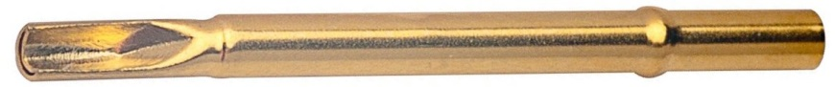
Wire is stripped and positioned against this area, then soldered into place.
Wire size is stated on the applicable Technical Drawing.

WIRE WRAP
Wire is wire-wrapped around the square post, and can be additionally
soldered if preferred.

Assembling the Probe
The spring probe is pushed into the open end of the sleeve:
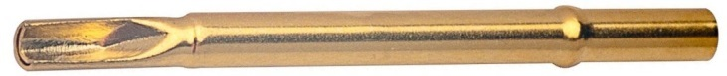

The probe should be pushed all the way into the sleeve – so that the body of the probe is completely within the sleeve, and the end of the body lines up with the opening of the sleeve:
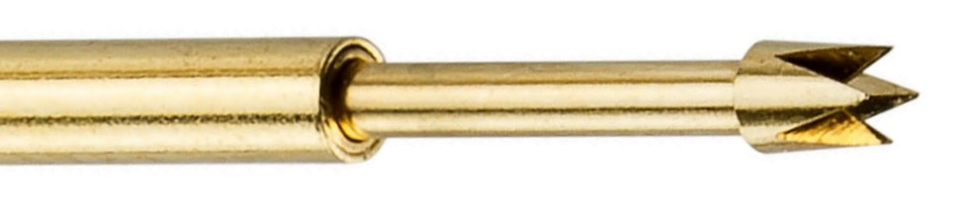
The resistance felt during the insertion is the probe body pressing past the indent in the sleeve – this will retain the probe in the sleeve once the probe is fully inserted.

Removing the Probe
The spring probe can be simply removed by pulling on the plunger to overcome the resistance of the sleeve indent. The holding force of the plunger in the probe is far greater than this resistance, so there is no possibility of accidentally removing the plunger and leaving behind the probe body in the sleeve.

ONE part Spring probes
Overview
The One Part Spring Probe is purchased as a complete assembly:
Retention Shoulder
Wire attachment
Head
Travel
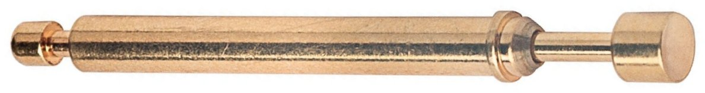
Plunger
Body (containing Spring)

Mounting the Probe
The probe is designed with a shoulder for a fixed projection height. The body is assembled through a hole in the test bed mounting plate, until the shoulder is flat to the test side of the plate. Once the probe is fully home, it can be fixed into place with solder, epoxy or other glue.
The Technical Drawings for the probes give a recommended mounting hole size applicable for this method.
To mount multiple spring probes of this style, it is recommended that the P1113XXX probes are assembled at a minimum pitch of 3mm to ensure electrical performance is maintained.
Once the probe is fixed in the mounting plate, the wire can be assembled to the rear of the probe. The recommended method is to strip a small length of the wire, wind it round the undercut on the rear of the probe, then solder in place. This should give both a secure attachment, and good electrical connection.

probe HEAD variants
Probe head styles should be chosen depending on the probe site chosen, and the level of contamination or coatings present.
Image | Head Style | Applications and Uses
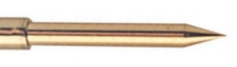 | Spear | Use on plated-through holes for negligible witness marks. Use on PCB lands and PCB pads. The point can penetrate thin layers of oxides, fluxes and contaminates.
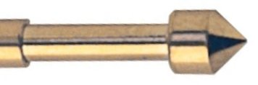 | Convex Point | Use on clean plated-through holes and connector sockets for negligible witness marks. Can be used on PCB pads. The convex point can penetrate oxides, flux residues and some conformal coatings.
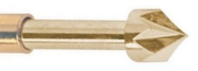 | Star | Use on contaminated plated-through holes, PCB lands and pads. The six sharp edges of the star wipe oxides and contaminants in plated-through holes.
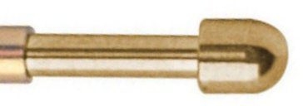  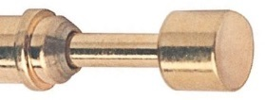 | Radius,  Convex Radius | Use on spring fingers or PCB pads and lands. The head does not leave a witness mark or indentation.
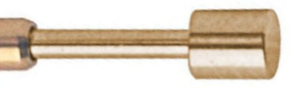 | Flat | Use on spring fingers or PCB pads and lands. The head does not leave a witness mark or indentation.
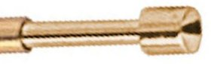  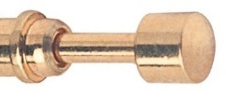 | Concave Point, Concave Radius | Use on clean leads, terminal pins, wire wrap posts and connector pins. The concave shape fits neatly over a round head terminal.
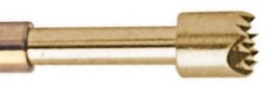 | Serrated | Use on slightly contaminated leads and pins. Suitable for ill-defined targets (those which may be slightly out of position). The head has multiple current paths, resulting in low resistance.
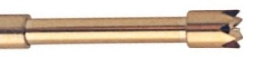  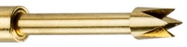 | Crown,  Tulip | Use on contaminated PCB lands, pads, long leads and terminal posts. The design allows contaminates to fall out, to become a self-cleaning head. The inside edges trap the leads to make contact. The multiple contact points give stability and low resistance.

Care and Maintenance
Prolonged use of the spring probe may result in contamination of the head. By-products of the soldering process, such as flux or solder residue, together with oil, dust and other contaminates can remain fixed to the head with potential contact problems.
It is recommended that the heads are cleaned regularly to ensure that contaminants are removed to prolong the lifespan and maintain performance of the spring probe. Two Part test probes can be removed from their sleeves for cleaning without having to disconnect any wiring. Brushing gently with a nylon or bristle brush is recommended.

